
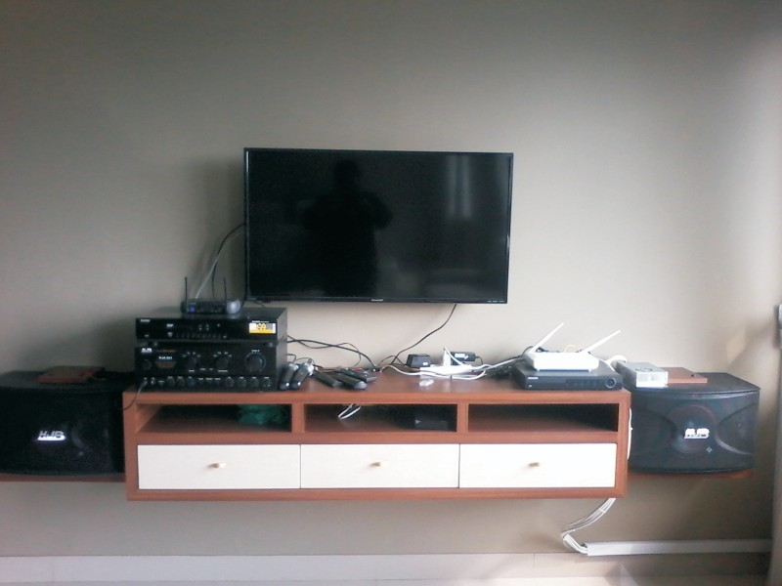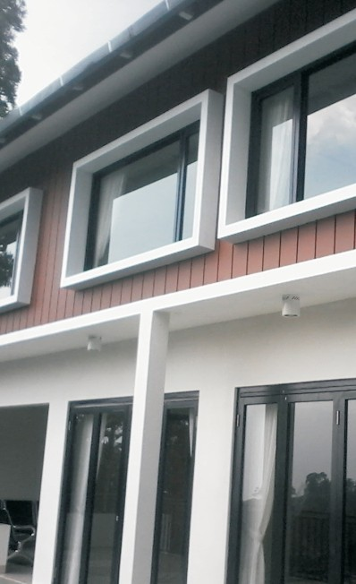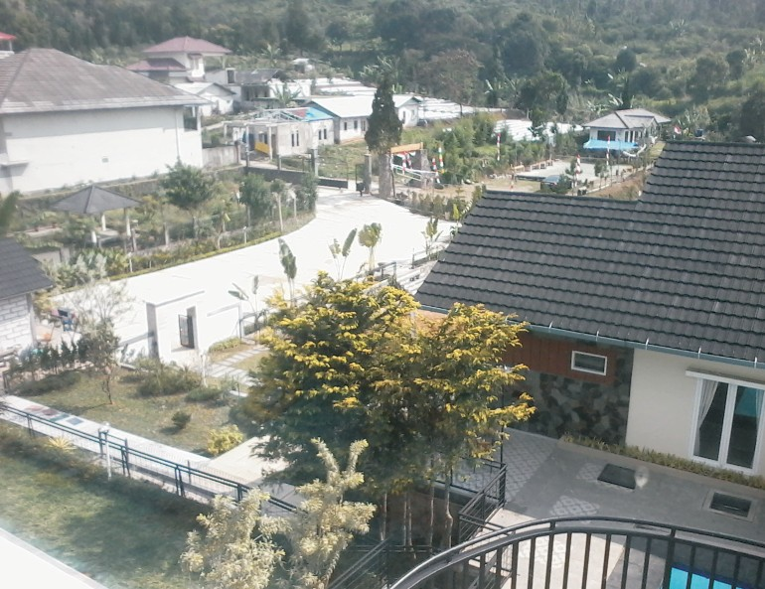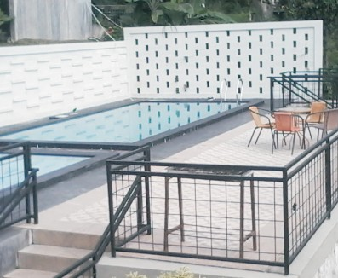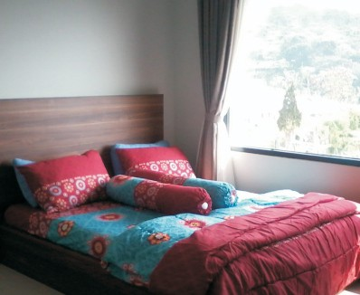#RV.003
image source: rajanyavilla publishing doc

VILLA LERENG PANGRANGO 1

BUILDING
Villa Lereng Pangrango 1 1 Bangunan Besar

PRICE
Weekend (Sabtu-Minggu) : Rp 4.500.000 Weekdays (Senin-Kamis) : Rp 4.000.000

ROOMS
4 ruang kamar tidur 6 ruang kamar mandi 5 extra bed (single)

SWIMMING POOL
Kolam renang anak Kolam renang dewasa

KITCHEN
Ruang Dapur Kulkas
Air galon Kitchen set Gas LPG

y
avilla.com
www.rajan

RESIDENCE CAPACITY
kapasitas ideal: 16 orang kapasitas max: 50 orang

CATERING
Rp 85.000 ( 3x makan)
Rp 95.000 (3x makan, 1x snack)

GAMES
Meja Billiard

IT FACILITY
WIFI TV
Sound Speaker

OUTDOOR SUPPORT
Lapangan parkir Lapangan outdoor Masjid/Mushola

LOCATION
Desa Cibeureum Cisarua Puncak

